


Committee on Committees Minutes

Associated Students
DATE: January 5th, 2026
LOCATION: Pardall Center Minutes/Actions recorded by: Shuyi Sum

CALL TO ORDER: 6:15 by Lily, Internal Chair

QOTW: What did you do over break? Any big plans for 2026?

A. MEETING BUSINESS

- Roll Call

Name | Note:  absent (excused/not excused)  arrived late (time)  departed early (time)  proxy (full name) | Name | Note:  absent (excused/not excused)  arrived late (time)  departed early (time)  proxy (full name)
Sophia Fei | Present | Yeshua Valdez Rodriguez | Excused
Lily Strange | Present | Savanah Lizet Aldaba | Present
Shuyi Sum | Present | Adam Orenstein | ...
Oliver Ramirez Carrera | Present | Rylee Bones | Excused
Layla Hakim | Excused | Archish Prakhya | Excused
Mira Ikladious | Present

- Acceptance of Excused Absences

MOTION/SECOND: Shuyi/Mira
Motion Language: Motion to excuse Layla, Yeshua, Rylee, and Archish from tonight’s meeting.
ACTION: Consent

- Acceptance of Proxies

B. PUBLIC FORUM

- EXTERNAL REPORTS

- Advisor’s Report

- Executive Officer’s Report(s)

- Group Project/Member Report(s)
  - Advisor and Senate Liaison Reports

Lily Strange - Internal Chair
    - Honoraria update
    - We got our budget request approved! Let’s brainstorm potential outreach initiatives for the year!
      - Here are the ones we had on our request
      - If anyone wants to take point on one of these, please let me know!
      - For the tablecloth, thoughts on getting a plain white canvas cloth and painting it? Could be cheaper. We do now have the budget for a printed one, would be ~$100
        - Now that we have $$, I can order some tabling items for us

        - Does anyone want to design cute stickers?
          - Examples from my COSWB co-chair
        - 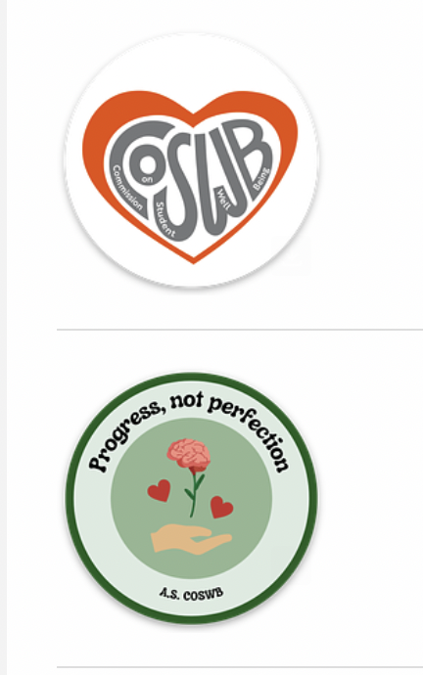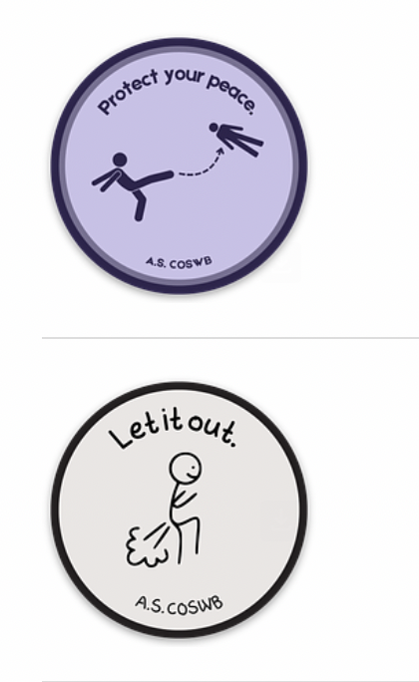
    - Hiring
      - Need to update the spreadsheet, maybe we can do a check in to any orgs still on there, if they are still hiring, if so, what support they need from us → Oliver this can wait until after the chairs meeting
      - One pro temp position left → senior advisor
      - OSA has an open position we are hiring for
      - Let’s make a post, something like make your new years resolution to join AS / new year new AS positions, etc
    - Chairs meeting → Oliver
      - Next Monday! We should email about this tonight to the AS Chairs email list
      - I made a doc with a loose outline, most important is sending an announcement / reminder ASAP
      - Let’s pass money for catering, any ideas for food?
      - What main reminders should we emphasize?
        - Those forms for requisitions and honoraria Sean sent
        - AS newsletter (internal and external)
        - Open position spreadsheet, as always
        - Updating meeting times in the winter quarter meeting times spreadsheet
        - Honoraria update (pending senate this week)
        - Liaison committee info from that email
        - Bonding activity → find someone from another group, think of a new years resolution your entities have in common to serve the student body / advance your mission
        - Relevant info from F25 slideshow (how appointments work, anonymous feedback form for AS in general)
      - Schedule for help at setup! Put your name under if available
        - ??-5:30pm → pick up the food, transport to UCEN
          - Sophia, Savanah
        - 5:30pm → someone else makes sure the UCEN room is set up + unlocked
          - Shuyi, Mira, Oliver, Rylee
        - 6pm → start
          - Lily, Shuyi, Layla, Rylee, Archish
        - 7pm → cleanup
          - Lily, Shuyi, Layla, Rylee, Archish
    - Pearman Fellows
      - Joining us next week! Since our meeting is at 6:15pm, and the chairs meeting is at 6pm, we will have to meet right after (like last time), but it will be pretty short
      - Hoping to do some bonding activity end of week 2 or start of week 3 for our quarter retreat + to introduce the pearman fellows to everyone
        - Ideas?
        - After feedback last quarter, I will be adding more training docs to the drive, position outlines / role expectations, etc
        - We could do a kahoot? After review of those materials? Is that lame….
        - We can also do a speed dating type exercise !
        - Either way, there will be free food
    - Who is tabling at the involvement fair?
      - Tuesday, January 13 from 11am-1pm PT, check in 10-10:30am at the SRB
        - 10:20-11am → Oliver
        - 11am-12pm →
        - 12pm-1pm →
      - Those who set up will need to get our tabling supplies from the CoC room in AS Main

Sophia Fei - External Chair
    - Chairs meeting planning, catering, email list?
      - Shopping for chairs meeting
      - Transportation
      - Check whats left for shopping…
    - Plan retreat for new quarter
    - Peerman fellows meet this week?

Shuyi Sum - Vice Chair
    - Coffee w the Pres:
      - Tabling went really well :D
      - Talked w Le Anh and we decided it would be good to send someone from CoC to each of the Coffee w Pres tablings this quarter ⭐⭐⭐
      - Plastic stand w QR code to the website and printed flyers of current open positions
    - Retreat !!

Oliver Ramirez Carrera - Internal Liaison

VACANT - Internal Liaison

Layla Hakim - Outreach and Recruitment Coordinators

Mira Ikladious - Outreach and Recruitment Coordinators
- Get to chairs meeting at 5/530 to set up
- Promote the last position?

Yeshua Valdez Rodriguez - Outreach and Recruitment Coordinators
    - Winter Involvement Fair 2026
      - Tuesday, January 13, from 11 am-1 pm PT at the Student Resource
      - Map
      - We should still have tabling supplies

Savanah Lizet Aldaba - Outreach and Recruitment Coordinators

Adam Orenstein - Commissioner of Community and Climate

C. Action Items

- ACCEPTANCE of AGENDA/CHANGES to AGENDA

- CONSENT ITEMS

- Approval of our Action Summary/Minutes from:

- ACTION ITEMS

F-1. Old Business:

F-2 New Business:

- DISCUSSION ITEMS

- Discussion Topic

- REMARKS

- ADJOURNMENT

MOTION/SECOND: Sophia/Savanah
Motion Language: I motion to adjourn this meeting at 7:20pm.
ACTION:CONSENT

